1) Install nginx and run nginx on port number 81.

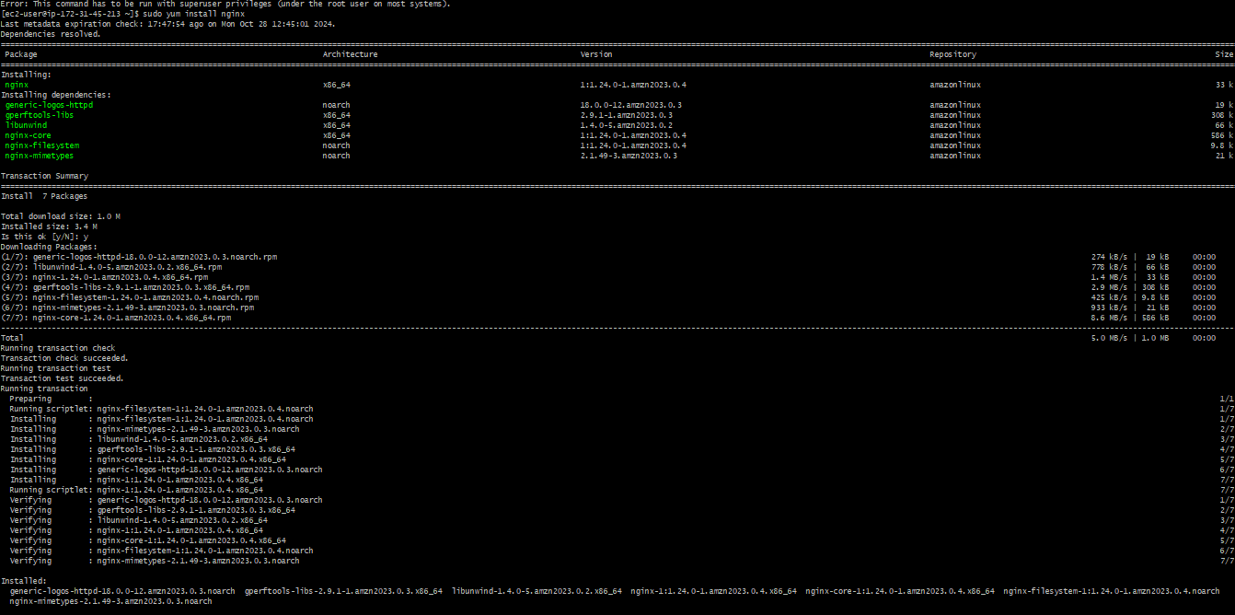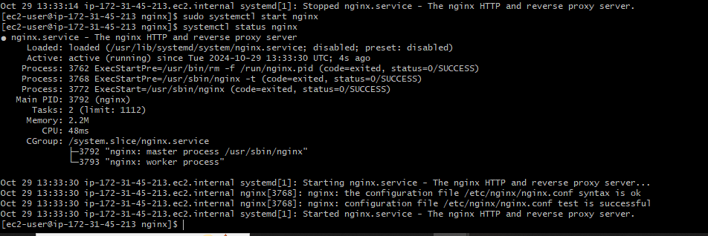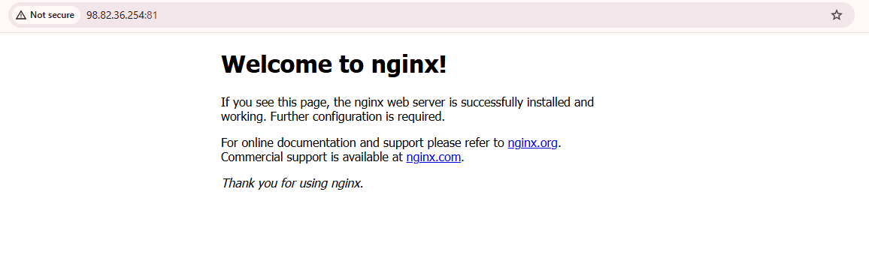

2) Deploy a sample index.html file on nginx.

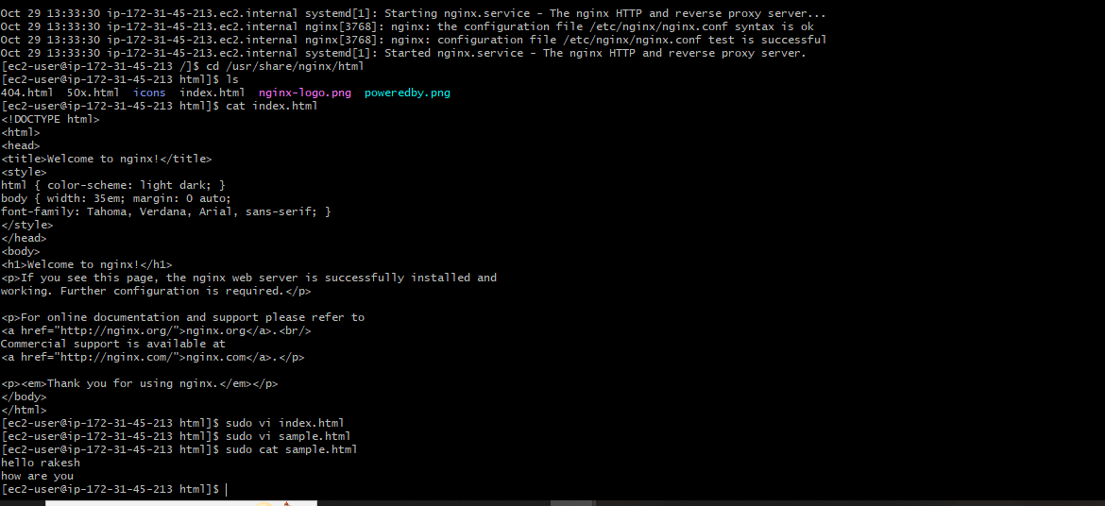

3) Install Apache and run Apache on port number 82

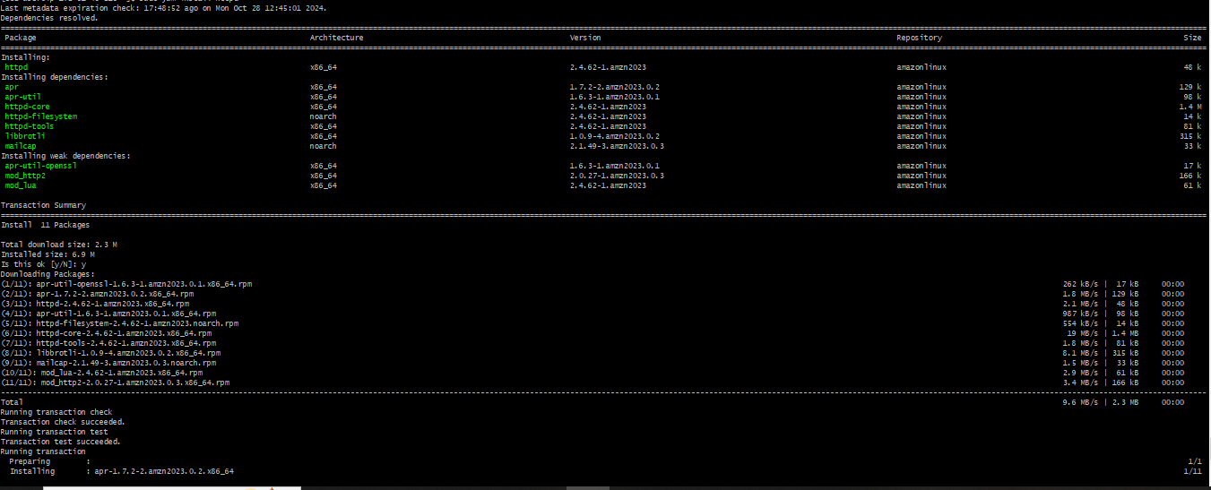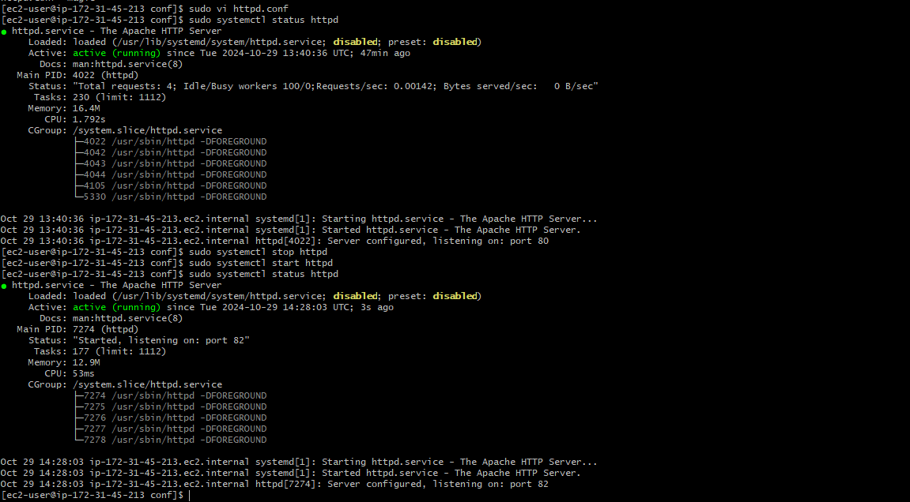

4) Deploy a sample index.html file on Apache.

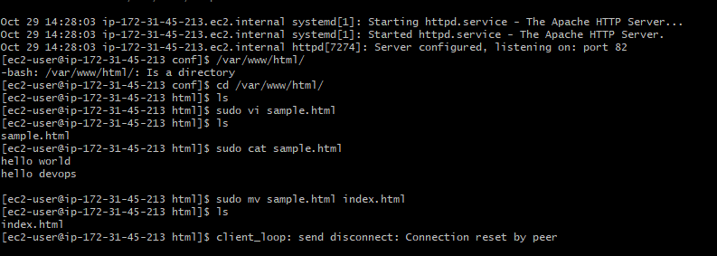

5) Install Apache tomcat on port number 8082

6) Deploy a sample app on webapps

7) Create a tomcat.service file for tomcat.

8) Configure HA Proxy server